Title: Discovery Center App

Authors: Osmar Coronel and Steven Rodriguez

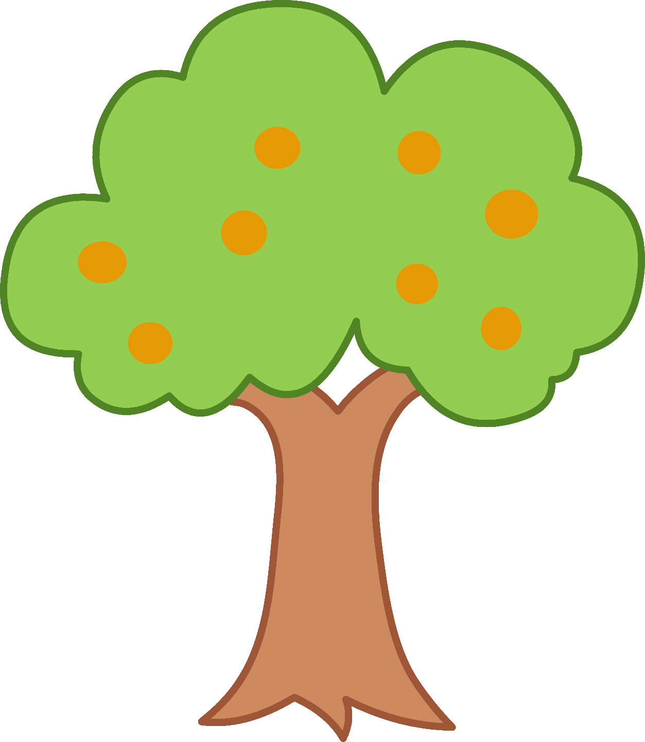

Abstract: In the background section our internship at MODS and the exhibit we chose. In Methods we will talk about what tasks each of us did. In Results we will show our app and what it does. In Discussion we will talk about additional information to complete our App. Conclusion will be about our thoughts on the app. Recognition will be to recognize everyone who made this possible

Background:

The Internship to us was a way to get real world experience in a working environment and learn some more about coding as we both are interested in studying Computers in College. It was a great learning experience as we first had time to learn about the inner workings of the museum before we were able to choose our exhibit. When we were allowed to choose our exhibit, both of us asked Summer about what would be needed for each exhibit. We chose Discovery Center because she said that it will be hard to make an app for the exhibit and we wanted a challenge.

Method: When the class first started Steven had experience in coding and Osmar had experience in graphics, but we both wanted to learn something different and so we decided to both go in to go and separate in to what we both had less experience in. As the class continued though, since we were only a group of two, no one could go to graphics as we were told to split in to Java and UI and so Osmar had to take up the graphics. Osmar was the Java/Coding and Graphics coordinator, and Steven was the UI coordinator and project manager.

Results: 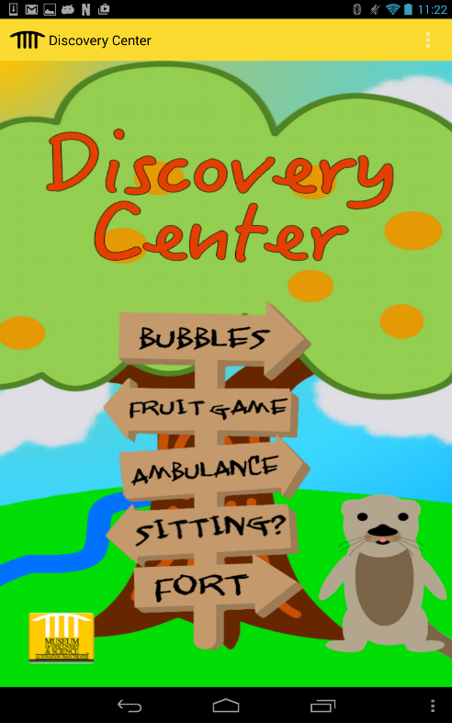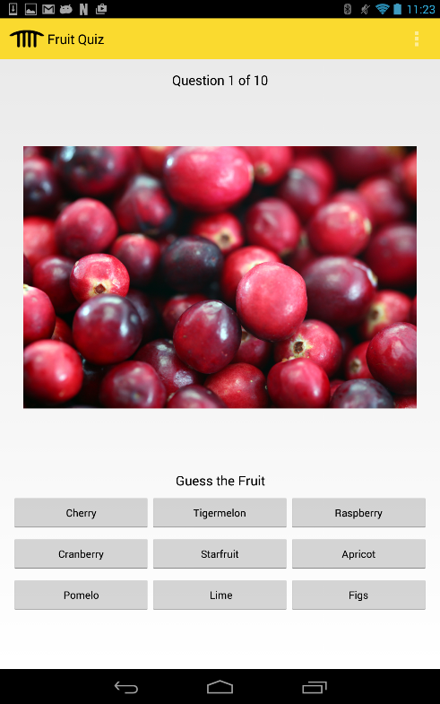

On our main page we have five different directions of Bubbles, Fruit Game, Ambulance, Sitting?, and Fort. Bubbles and Sitting? Are both videos made to teach kids how to use the bubble table and to tell parents what they can do with their children instead of sitting, repsectively. Fruit Game leads to a quiz game where it shows you a picture of a fruit and you hace to guess what the name of that fruit is. Ambulance is where you see a picture of an ambulance, firetruck, and police car and when you click on the pictures it makes the noise that that car makes. Fort leads to all the credits of who made the app and who helped us along the way.

Discussion: The rest of what we want to do is add more fruits to the fruit game, and to integrate our app, and every other app, to the hub app both Osmar and I made where you can access every app both by a representative icon and by the interactive map we added.

Conclusion: We really like how our app turned out. We were given a tough task and we think we hit the mark very well. It reaches greatly to the children demographic our exhibit is intended for. We put a lot of work into everything the app has, from all the differnet things the app can do to the cartoon graphics we made by. You can find our app in the Discovery Center repository on Github.

Acknowledgements: We would like to thank everyone who this this possible. Our school, Archbishop Edward A. McCarthy for allowing us to fully be a part of the class and internship. We would especially like to thank Dr. Ugalde and the Guidance Department at AMHS for telling us about this program and giving us help every step of the way with signing up for the internship and class. We would like to also thank the Museum of Discovery and Science, and especially Summer Scarlatelli and Joe Cytacki for giving us this wondering opportunity and giving us great advice in a museum perspective. We would like to thank FAU, and all the teachers ( Dr. Shanker, Professor McAfee, and Dr. Mitsova Boneva)and TAs (Santiago Aguerrevere, Alain Edwards, and Demetrius Dukes) for helping us create the app by teaching us how to use Android Studios, and for helping us with any problem we had. We finally would like to thank United Way Broward for providing the grant that made this all possible.

References: We used Android Studios to create the app. We used Photoshop and Pixel8ater for the graphics of the app. We also used Sudoku and Flagquiz for references in how to create an app.